16. Write a C program to arrange a series of numbers using Insertion Sort

**Aim:**To write a C program that sorts a series of numbers in ascending order using the **Insertion Sort** algorithm.

**Algorithm: InsertionSort**

Input: An array A[0..n−1] of n numbers

1. For i = 1 to n − 1 do

key ← A[i]

j ← i − 1

/* Move elements of A[0..i−1] that are greater than key

to one position ahead of their current position */

while j ≥ 0 and A[j] > key do

A[j + 1] ← A[j]

j ← j − 1

end while

A[j + 1] ← key

2. End for

**Program**

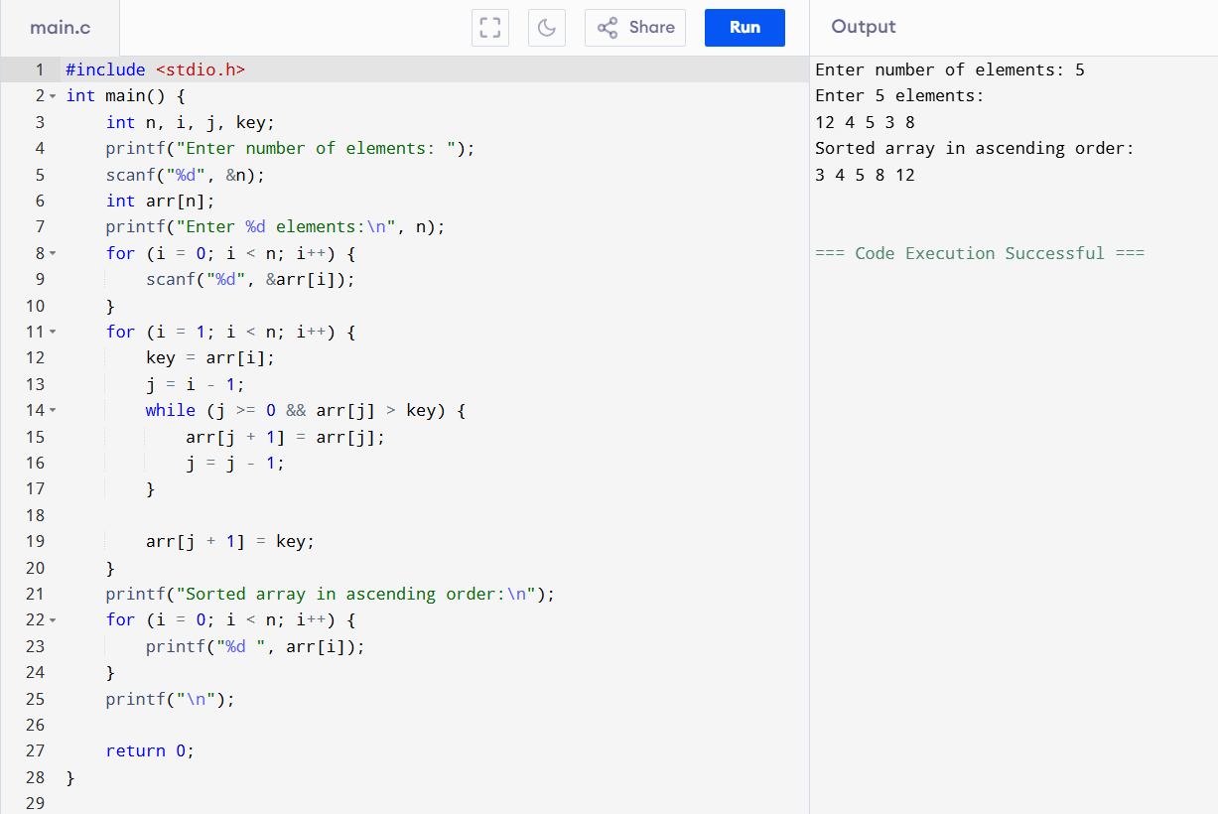

**Result:** The program has been executed successfully and output is verified.